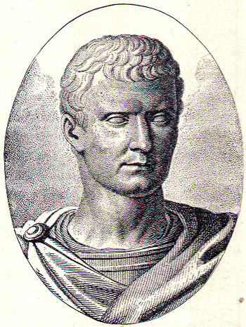
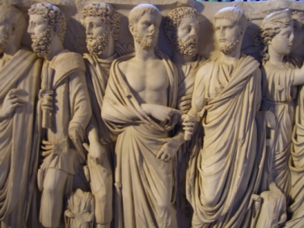
Ancient Rome WebQuest

Ancient Rome was a civilization that achieved great things. The people had a unique way of life and strengthened themselves to become an empire. Take a trip back to the ancient world where all roads lead to Rome! During this virtual assignment, you’ll need to take notes about your learning. Let’s begin the step by step process:

- Save this document and your progress as you go along. Type right into the gray text boxes starting at the arrows (>>). The boxes will expand if you need more space.
- Use control and click on the blue links to go to websites for your information.

- Begin your tour of ancient Rome by reading about the legend that began it all: Romulus and Remus. When you are finished reading, take the 10 question quiz by clicking on the link at the end of the story, or by clicking here.
What score did you get on your quiz?
>>

Summarize the story of Romulus and Remus in about 5 sentences:
>>

- Famous or infamous, the Roman leaders made their mark! Read about some of the more well-known Romans.
Which Roman became a dictator but was then assassinated by his friend Brutus?
>>
Which Roman was known as “The Philosopher King”?
>>
Which Roman emperor ruled during a time of peace called the “Pax Romana”?
>>
Which Roman was the first emperor and was originally named Octavius?
>>
Which Roman was in power during the “Great Fire of Rome” and was also suspected of starting it?
>>

Which Roman was the first Christian Emperor who moved the capital of the empire from Rome to a town called Byzantium, which he renamed after himself – Constantinople?
>>

- Daily life in Ancient Rome was full of activity! Read about the day to day activities of the Romans. After reading, take the 10 question quiz by clicking on the link at the end of the webpage, or by clicking here.
What score did you get on your quiz?
>>

What jobs did Ancient Roman people have?
>>

- Women have fought for equal rights throughout history. The same is true for the women of Ancient Rome. Read to find out more.
What were the three classes that women fell into?
>>
After Rome became an empire, women had some rights. What were they?
>>

- The Pantheon is an important building in Italy. It was built by the Ancient Romans and is still in use today!! Take a look at these pictures and read more about the Roman Pantheon.
What was the Pantheon originally built for?
>>
How is the Pantheon used today?
>>

- Now let’s visit the Roman Colosseum. Read and watch a video to learn about this amazing stadium of Ancient Rome. Click HERE
How did Romans use the Colosseum?
>>

- Would you want to be a gladiator? Find out. Read about gladiators on this page.
Name and describe 3 different types of gladiators.
>>

- If you think gladiators were brutal, you’re right! But they weren’t the only ones! Some of the Roman leaders, such as Nero, were equally ruthless. It is said that he set Rome on fire and played a fiddle while the city burned! But did that really happen? Watch this video to find out!
What is your opinion of Nero? Good guy or bad guy? Explain why using details.
>>

- The people of Rome wanted a fair government and fair laws. Read about The Twelve Tables.
Do you think the laws of the Twelve Tables were fair? Support your answer.
>>

- The letters SPQR are written all over the place in Ancient Rome. Find out more about this significant acronym.
What does SPQR stand for and why was it written everywhere?
>>

- In Ancient Rome, you may have been a Plebeian or a Patrician. Find our more before you decide which one you would have liked to have been.
Which would you want to be: a Plebeian or a Patrician? Tell Why.
>>
What was “The Conflict of the Orders”?
>>

- Ancient Romans were great builders and engineers. One of the most impressive things they built was the aqueducts. Watch this video to see how they did it.
What did the aqueducts allow Rome to do?
>>

- The Roman Military was divided into two main groups: The Legions and the Auxiliaries. Summarize these two main branches of the Roman army in the chart below:
Legions | Auxiliaries
>> | >>

- The Romans had a strong belief in their gods. Some of the gods were “borrowed” from other religions. Take a look at these websites to complete the scavenger hunt by writing the missing names or descriptions.
Link 1 Link 2
Names of the Gods | Description of the Roman Gods
>> | King of the Gods
Neptune | >>
>> | Three-headed dog that guarded the entrance to the underworld
>> | Goddess of wisdom
>> | God of music, poetry, and archery. He was also the god of the sun.
Vulcan | >>
Mars | >>

- The Ancient Romans left many artifacts that we can learn from today. Take a look at the pictures of artifacts below. First, fill in the “Prediction” column to tell what you think the artifact is. Then use this webpage to research more about them and see if you were correct. Finally, write a short description of each artifact in the chart.
Picture of Artifact | Prediction | Description of Artifact
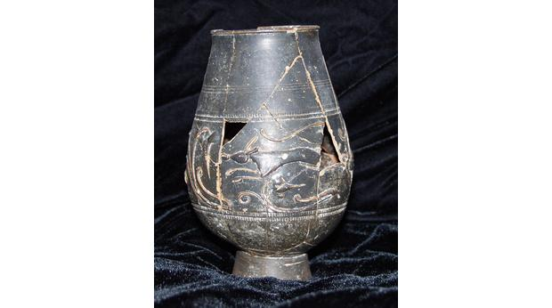 | >> | >>
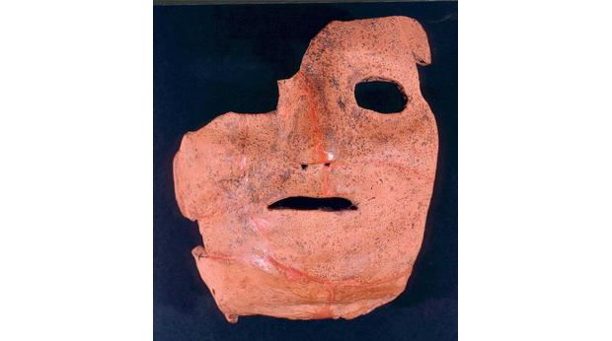 | >> | >>
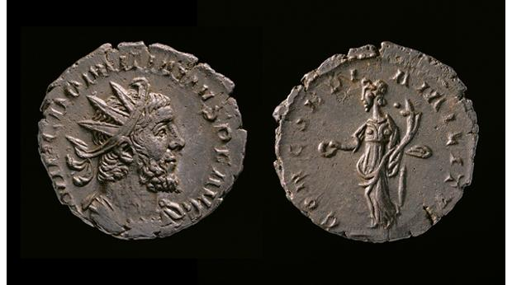 | >> | >>
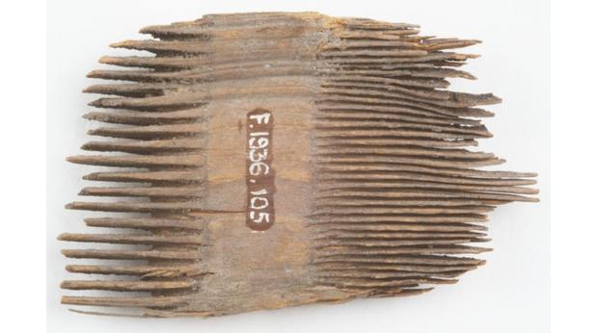 | >> | >>

- Take a look at these pictures of Roman temples. Do you notice anything?
What architectural feature do these temples have in common?
>>

- The Roman Empire grew and controlled a lot of land…maybe too much land for its own good. Take a look at this map that shows the expanse of the empire.
Which body of water does almost all of the Empire of Rome surround?
>>

- The Roman Empire didn’t last forever. Read about the “Fall of Rome.”
List some factors that contributed to the Fall of Rome!
>>

