Creative Thinking Challenge
Look around your home and see how many things are shaped like letters of the alphabet.
Your challenge is use everyday household objects to write your first name (no shortening)….no real letters allowed.
If you are looking for a bigger challenge try to find things that will make your whole name freestanding instead of lying down.
When you are done take a picture and email it to me at: htandy@sd57.bc.ca
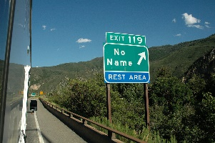
**Just think …with this task we won’t have any No Names!**

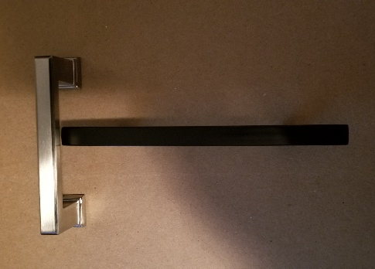
Example:
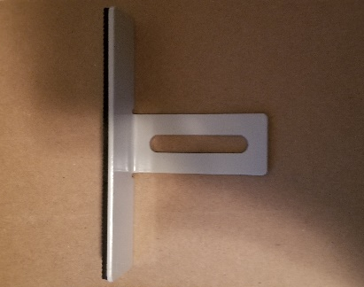
Using 2 cabinet handles to make a T

Using a bracket from a shelf that is shaped like a T

