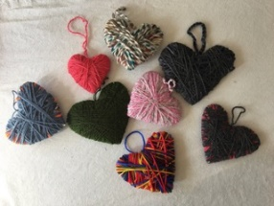
Division 15 Learning Plan – April 14 – 17

Good afternoon everyone. I hope you all had a great Easter weekend. I bet it looked really different for many of you. My family did a big zoom chat on Easter Sunday and included people from Germany, Victoria, Vancouver, Calgary and PG. I also really enjoyed the weather…it is starting to feel like spring!
Over the next week you should expect to be working on school work for about 2 hours a day. One of the first tasks I’d like you to get into the habit of doing is filling in the attached schedule of when you are going to do each subject. It is ok if the schedule changes a bit throughout the week but it will help you to have a plan.
As you start handing work in to me by email I would appreciate it if you could make the subject line your name and the assignment.
For example: TandyHeather schedule.docx
Online meetings this week:
Watch for consent forms that the district is sending out sometime this week. Once those are all in (digitally) we will be able to have a class meeting online. I am hoping this will be by the end of the week or early next week.
Numeracy: 30 minutes Mathletics
I will be emailing out a login for each of you to use. The web address is with the login information. I have assigned some work for this week that should be very straight forward. The goal will be to get used to using the program. Plan on doing about 30 min a day. As I see you completing work I will be assigning new work. I plan to start our new units next week so use this time to get familiar with the program. Please email me if you have any difficulties or questions!
Literacy: 30 minutes
- Your task this week is to start journaling your thoughts, feelings, and experiences regarding the pandemic. You are currently living through an interesting period in world history. Someday your children, grandchildren or others will be interested in hearing what it was like just as you found it interesting to learn about World War II earlier this year. Please see the attached document outlining your journaling assignment. This is a task that you will be completing over a number of weeks and you should focus on quality over quantity. Please email me your journaling plan and any work you’ve completed by the end of week.
- Read a bit every day! Let me know what books you are choosing to read. If you wish you can even send me a little book review that explains what you think of the book.
Wellness: 60 min per day
- get outside and move at least once a day
- continue to work on your yoga using the link from last week
- Spelling your name through workouts (attached to this email)
- Check out the virtual workouts at the y
https://nbc.ymca.ca/your-virtual-y/
- Try something new….cook a new recipe, random acts of kindness, or a craft. Some sample ideas that have come from you students in our class:
  - Sarah’s hearts: See the photo at the top of this page? Cut out cardboard hearts and wrap them with leftover yarn scraps….these would be great to hang in your windows.
  - Alaina’s restaurant: Create a proper menu and present your cooking as if you were in a high end restaurant! Your family will love it!
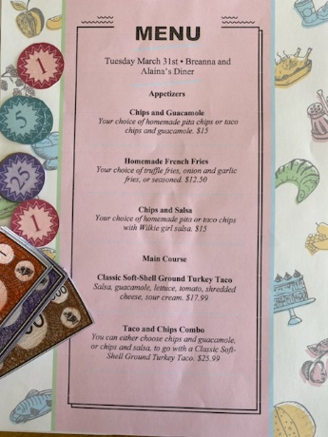
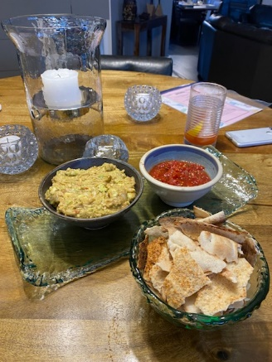

Please keep sending me pictures of what you are up to and I am happy to share a few each week!
Attachments that you need for this week:
- Enjoy the names power point….I will make a second power point when I get the rest of the names in!
- Schedule for the week
- Journaling Assignment
- Mathletics Login (in a separate email)
- Watch for zoom consent forms (likely being sent from the district later this week)

