Division 15 Learning Plan – April 20-24
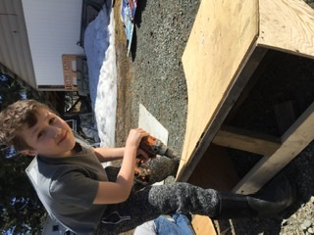
Good afternoon everyone. I hope you all had a chance to get outside in this great weather. Our snow is almost gone! Just think we are missing the time of year when the field stinks so badly!
Over the next week you should expect to be working on school work for about 2 hours a day. The first task you are going to have will be to complete the website scavenger hunt and hand it in on the website.
I am getting a crazy amount of email right now so am really appreciating your efforts to name your files with your name and the name of the task.
For example: TandyHeather scavenger hunt.docx
Online meetings this week:
Please keep submitting those consent forms. I will set up an online meeting for us as soon as I get the go ahead.
Numeracy: 30 minutes a day Khan Academy and Mathletics
“It’s not a negative thing if you have a positive attitude about it!”
We are going to start working on an Integers unit this week. The order to do your work in is laid out in the schedule.
You will find links to Khan Academy videos in the numeracy section of the website. These videos do a good job of teaching you about integers. I have assigned Mathletics practice that you can do along with the video. My side of Mathletics lets me know how much you have done and shows me your growth and improvement.
If parts of this aren’t making sense please email me and I will give you a call to try and help.
Literacy: 30 minutes Scavenger Hunt, Journalling, Poetry Unit Intro
- By now you should have completed and submitted your scavenger hunt worksheet.
- Continue to work on journaling your thoughts, feelings, and experiences regarding the pandemic. Remember to look over the marking rubric to get ideas of all the things you can write about. Also remember that some of your journal can be done in pictures or short videos.
- On Wednesday we will be starting a unit on poetry. This will involve creating a poetry collection of your own. Watch for more information on Wednesday!
- Read a bit every day! Let me know which books you are choosing to read. If you wish you can even send me a little book review that explains what you think of the book.
Wellness: 60 min per day
- Check out the wellness section of the website for links to activities.
- Get those bikes out and tuned up…be sure to wear a helmet and be road aware!
- Do your own thing….and share what you’ve been doing to stay active. I’m sure your parents could use some help cleaning up the yard!

Creative Choices
- Keep trying new things. Here are some samples of what some of you got up to last week.
  - Avoly has been working on crotcheting a small scarf
  - Cage has started a woodworking project….a custom spoon. Maybe it can be used to eat the egg from the eggdrop challenge he took on!
  - Jake has researched, designed and built a bike jump. (see photo above)
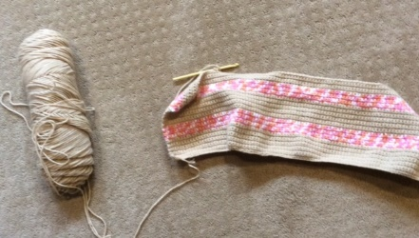
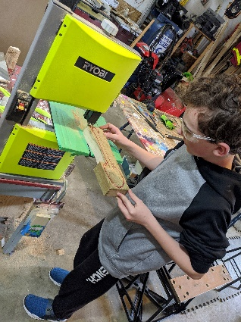

Please keep sending me pictures of what you are up to and I am happy to share a few each week!
Attachments (from the website) that you need for this week:
- Schedule for the week
- Journaling Assignment (from last week)
- Khan Academy video links
- Mathletics Login (in a separate email)
- Watch for zoom consent forms (sent from the district last week)
- Poetry collection assignment (coming out Wednesday)

Please don’t hesitate to contact me if you have questions or just want to chat about what you are learning or doing! I will be trying to connect with each of you at least once this week!

