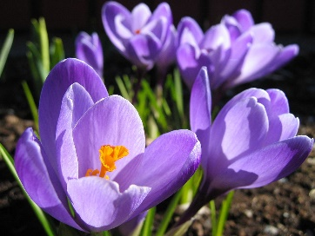
Division 15 Learning Plan – April 27 – May 1

Good morning everyone. I am looking so forward to connecting on zoom this week. We will have a full class meeting and then I plan to meet with small groups in Math. You should expect to be working on school work for about 2 hours a day. You guys are doing a great job of handing things in and I have been working on an efficient way to give you feedback on your work. Watch for an email tomorrow with feedback on your work from the last few weeks.
Online meetings this week:
Whole class Zoom – Monday 10:30am See the email sent out last week with the link and sign in names and instructions.
Tues, Wed, Thurs – Math Zoom lessons links will be emailed out
Numeracy: 30 minutes a day Zoom lessons, Khan Academy, Mathletics
I am breaking us into groups for Math this week. The Grade 7’s will continue their work on integers. The Grade 6 students have completed all they need to do with integers and will be starting a unit on area and perimeter this week. I will be letting each of you know which group you are in.
You will find links to Khan Academy videos in the numeracy section of the website. These videos do a good job of reviewing the teaching. I have assigned Mathletics practice that you can do along with the video. My side of Mathletics lets me know how much you have done and shows me your growth and improvement.
On Friday at 10:30am I have assigned a live problem solving challenge. If you are able to, log onto your Mathletics at 10:30. You will have up to 60 min to complete the challenge. There is a screen on the right that will let you ask me for hints or help as you try this.
If parts of this aren’t making sense please email me and I will give you a call to try and help.
Literacy: 30 minutes Journalling, Poetry Unit - lyrical poetry
- Read the worksheet and activity on Lyrical poetry (think music!)
- Add the information about lyrical poetry to your poetry glossary
- Continue to work on journaling your thoughts, feelings, and experiences regarding the pandemic. I will be giving you some ideas for this when we talk today.
- Read a bit every day! Let me know which books you are choosing to read. If you wish you can even send me a little book review that explains what you think of the book.
Wellness: 60 min per day
- Check out the wellness section of the website for links to activities.
- Get those bikes out and tuned up…be sure to wear a helmet and be road aware!
- Do your own thing….and share what you’ve been doing to stay active. I’m sure your parents could use some help cleaning up the yard!

Creative Choices
- Keep trying new things. Here are some samples of what some of you got up to last week.

Finn is building a model airplane.
Nick is training a new puppy.
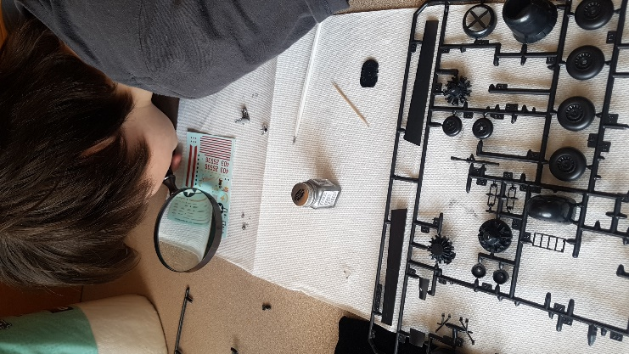
I hear quite a few of you have been eating CORN.
Please keep sending me pictures of what you are up to and I am happy to share a few each week!
Attachments (from the website) that you need for this week:
- Schedule for the week
- Journaling Assignment (Living through Covid-19)
- Khan Academy video links
- Mathletics Login (in a separate email)
- Lyrical Poems Assignment
- Types of Poems Glossary (continued from last week)
Please don’t hesitate to contact me if you have questions or just want to chat about what you are learning or doing! I will be trying to connect with each of you at least once this week!

