Division 15 Learning Plan – June 1-4

These days our worlds seem to be in a constant state of change and new changes are coming again this week. I am excited to be welcoming some of you back to the school this week. If, on the district survey you said yes to returning you should have received an email by now with instructions on which day of the week you are returning. If you indicated no or maybe on the form and would like to consider attending June 8-12 your parents need to contact the office to let them know your plans. I’d appreciate an email as well as it will assist me in my planning. Our online zoom meetings will now all be happening on Wednesdays.
Online meetings this week:
An email has been sent out with the links.
Group 3 Math – Wed 10:00am
Group 2 Math – Wed 10:45am
Group 1 Math - Wed 11:30am

Numeracy: 30 minutes a day Zoom lessons, Khan Academy, Mathletics
Group 1 will be continuing their work on decimals, fractions and percents. Group 2 will continue working on measuring angles. Group 3 will continue working on fractions.
I missed most of you in problem solving last week. Gold stars to Jo and Alaina for showing up and working hard. We will do Mathletics Problem solving again this week on Thursday at 1pm. It will be live at 1pm for those that are available for it. If you haven’t done any of the Math problem solving yet it would be good to try and join in.
Literacy: 30 minutes a day Journaling, Ancient Rome
- This is your week to get all of your overdue poetry stuff complete and up to date.
- We are going to be working on reading non-fiction material for the next few weeks. We will be learning about Ancient Rome through a Webquest. Download the Ancient Rome Webquest from the Literacy page and save the document to your computer. It contains links to interesting reading, videos, interactive games etc. Your task over the next 3 weeks is to complete the webquest. Your responses to each section go into the grey boxes (they will expand for you). Work through it at your own pace but be sure not to leave it all until the last minute. When it is done please hand it in through the website.
Creative Choices
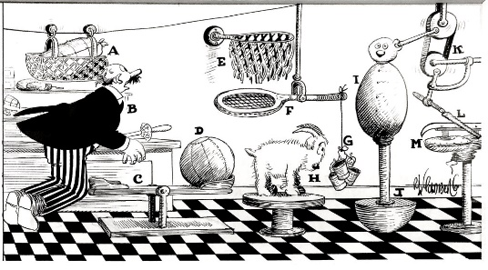
I am still waiting to see those cool Rube Goldberg machines. Links for ideas are on the creative choices section of the website. In class students will have a chance to work on these at school this week.

Wellness: 60 min per day
- My daughter, Megan, has made some workouts for you. Check out Moving with Megan Part 1 on the Wellness page if you want to work out with an Olympian.
- Do your own thing….and share what you’ve been doing to stay active.
- As you explore more outside be sure you are making good choices and staying safe!

Attachments (from the website) that you need for this week:
- Schedule for the week
- Journaling Assignment (Living through Covid-19)
- Any missing poetry work
- Ancient Rome Webquest
- Links to Moving with Megan Part 1
- Links to the Rube Goldberg Challenge
Please don’t hesitate to contact me if you have questions or just want to chat about what you are learning or doing

