Division 15 Learning Plan – May 11-15

What gorgeous weather these days! It may be time to come up with a plan to help you stay on top off assignments while still enjoying being outside. This good weather will make it easier to procrastinate You may have also heard a lot on the news about plans for schools to start opening again. These plans are pretty vague right now but know that I will let you know anything more specific as soon as I get official information. In the meantime, keep doing a great job of the work you are doing. I am so impressed with the steady improvement in your journals!
Online meetings this week:
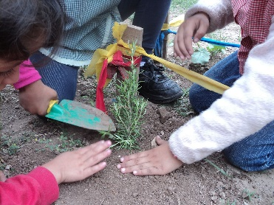
See the email sent out last week with the links.
Whole class Zoom – Monday 11:00am
Group 3 Math - Tues. 11:00am
Group 2 Math – Wed 11:00am
Group 1 Math – Wed 1:00pm

Numeracy: 30 minutes a day Zoom lessons, Khan Academy, Mathletics
We will continue to work in groups this week. Group 1 will continue their work on operations with integers. Group 2 students will be working on finding the area of parallelograms and triangles. Group 3 will continue their work on the fractions unit.
You will find links to Khan Academy and other videos in the numeracy section of the website. I have assigned Mathletics practice that you can do along with the video. Most of you are doing a great job on the Mathletics practice. Have you explored some of the games on there as well? It is a fun way to reinforce your skills.
On Thursday at 1:00pm we will do a virtual Breakout room. I will send you specific login information. I suspect this will take an hour or less….we will see. It is a long weekend so I hope you will be able to escape!
Literacy: 30 minutes a day Journalling, Poetry Unit - Poetic devices
- Look on the bottom of the literacy website page poetic devices.
- Add the information about these to the Poetic Devices chart that is also linked on the page.
- Your poetic devices worksheet will ask you to come up with your own examples of Similes, Metaphors and Onomatopoeia as well as have you identify them in poetry
- Continue to work on journaling your thoughts, feelings, and experiences regarding the pandemic. Start to think about how your entries can all be put together.
- Read a bit every day! Let me know which books you are choosing to read. If you wish you can even send me a little book review that explains what you think of the book.
Wellness: 60 min per day
- Check out the wellness section of the website for links to activities – I have added a new Kid’s Daily Workout Link
- Get those bikes out and tuned up…be sure to wear a helmet and be road aware!
- Do your own thing….and share what you’ve been doing to stay active. I’m sure your parents could use some help cleaning up the yard!

Creative Choices
- I have added a you Tube link to the Pringle Ring challenge. You will need 1 can of Pringles for this. Try it and then try and think of other foods that might also work for this.
- Try out the bottle rocket challenge. Look farther down the link for the steps to make it.
Please keep sending me pictures of what you are up to and I am happy to share a few each week! I am working on the addition of a video and photo sharing page on the website; if your parents are okay with me posting them please include that information with the photos and videos.
Attachments (from the website) that you need for this week:
- Schedule for the week
- Journaling Assignment (Living through Covid-19)
- Khan Academy video links
- Mathletics Login (in a separate email)
- Exploring Poetic Devices Assignment
- Poetic Devices Glossary (continued from last week)
- Links to the Pringle Ring Challenge
Please don’t hesitate to contact me if you have questions or just want to chat about what you are learning or doing

