Division 15 Learning Plan – May 19-22

What gorgeous weather these days! It may be time to come up with a plan to help you stay on top off assignments while still enjoying being outside. This good weather will make it easier to procrastinate You may have also heard a lot on the news about plans for schools to start opening again. These plans are pretty vague right now but know that I will let you know anything more specific as soon as I get official information. In the meantime, keep doing a great job of the work you are doing. I am so impressed with the steady improvement in your journals!
Online meetings this week:
See the email sent out last week with the links.
Group 1 Math - Wed. 11:00am
Group 2 Math – Wed 1:00pm
Group 3 Math – Thurs 11:00pm
Whole class Zoom – Monday 11:00am

Numeracy: 30 minutes a day Zoom lessons, Khan Academy, Mathletics
We will continue to work in groups this week. Group 1 will continue their work on order of operations with integers. Group 2 students will be working on finding the area of triangles. Group 3 will continue their work on the fractions unit. All 3 groups have tests coming up as they finish up their units.
You will review the links to Khan Academy and other videos in the numeracy section of the website. I have assigned Mathletics practice that you can do along with the video.
This week you can do the virtual Breakout room whenever it works for you. This one is more logic oriented and not based directly on your math.
Login at https://student.breakoutedu.com/login
Class code this week is TKB D46 The game that comes up is “Field Day Funnaniguns”
(Can you win the sports day?)

Literacy: 30 minutes a day Journaling, Poetry Unit - Poetic devices
- Poetry Research – Go online and complete the poetic devices glossary. You can also use the poetry links on the literacy page.
- Find 5 examples of poems that are good examples of Imagery, Hyperbole, Alliteration, Rhyme, Rhythm. Write a paragraph (5-7 sentences) for each poem explaining why it is a good example of that poetic device.
- Continue to work on journaling your thoughts, feelings, and experiences regarding the pandemic. Start to think about how your entries can all be put together. Your completed journal will be due in two weeks.
- Read a bit every day!
Wellness: 60 min per day
- My daughter, Megan, has made some workouts for you. Check out Moving with Megan Part 1 on the Wellness page if you want to work out with an Olympian.
- Do your own thing….and share what you’ve been doing to stay active.
- As you explore more outside be sure you are making good choices and staying safe!
Creative Choices
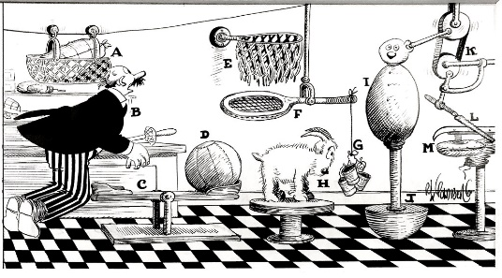
- A Rube Goldberg Machine creates a ton of actions and reactions to find complicated ways to do simple things. Check out the challenge to build one of these machines on the Creative Choices link.
- Try out the Pringles or bottle rocket challenge from previous weeks.
- Please keep sending me pictures of what you are up to and I am happy to share a few each week! I am working on the addition of a video and photo sharing page on the website; if your parents are okay with me posting them please include that information with the photos and videos.
Attachments (from the website) that you need for this week:
- Schedule for the week
- Journaling Assignment (Living through Covid-19)
- Poetic Devices Glossary (continued from last week)
- Links to Moving with Megan Part 1
- Links to the Rube Goldberg Challenge
Please don’t hesitate to contact me if you have questions or just want to chat about what you are learning or doing

