Division 15 Learning Plan – May 25-29

Last week was such a rainy week I am sure you are all looking forward to the good weather they are calling for now! This week you will be finishing up your work on poetry and starting to cover some new information in Math. You will also be finishing up your poetry unit. Use this week to show me what you have learned in poetry!
For those of you not coming back to the school next week I will be putting out online learning for you to work on. If you are coming back to school next week you may want to start getting up a bit earlier each day this week so 8:35 is not such a shock to your systems! We are busy at the school getting ready for you. Please know that at school we will all be working very hard to adhere to social distancing and safe hygene standards. There are some things that will be the same but quite a few things that will be different than what you are used to. More info on this will be coming out at the end of the week.
Online meetings this week:
An email has been sent out with the links.
Whole class Zoom – Mon 11:00am
Group 1 Math - Tues 11:00am
Group 2 Math – Tues 1:00pm
Group 3 Math – Wed 11:30am

Numeracy: 30 minutes a day Zoom lessons, Khan Academy, Mathletics
We will continue to work in groups this week. Group 1 will complete their work on operations with integers and then begin working on a short unit on converting Fractions, decimals and percents. Group 2 students will be working on measuring and drawing angles and triangles. Group 3 will continue their work on the fractions unit. If you haven’t completed last week’s work or your test you may want to make math a more specific focus this week.
I have added links on the website for each math group this week. Remember that you can also use the Info “i” on Mathletics which will give you a mini lesson and sometimes a video.
We will do Mathletics Problem solving again this week on Friday at 1pm. It will be live at 1pm for those that are available for it. If you haven’t done any of the Math problem solving yet it would be good to try and join in.
Literacy: 30 minutes a day Journaling, Poetry Unit - Poetic devices
- Poetry – Summative activity (see the worksheet link literacy page) This is your chance to showcase your learning. You will have a choice of creating your own poems or finding poems that you can analyse and respond to. The big idea is to include all the bits of learning you have done in the unit and pull them all together.
- Continue to work on journaling your thoughts, feelings, and experiences regarding the pandemic. Start to think about how your entries can all be put together. Your completed journal will be due next week.
- Read a bit every day!
Wellness: 60 min per day
- My daughter, Megan, has made some workouts for you. Check out Moving with Megan Part 1 on the Wellness page if you want to work out with an Olympian.
- Do your own thing….and share what you’ve been doing to stay active.
- As you explore more outside be sure you are making good choices and staying safe!
Creative Choices
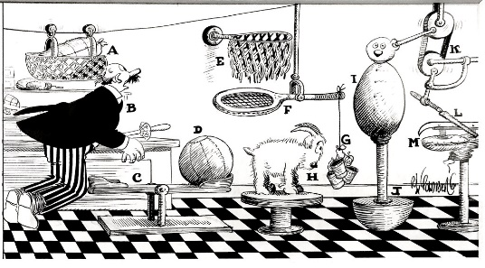
- A Rube Goldberg Machine creates a ton of actions and reactions to find complicated ways to do simple things. Check out the challenge to build one of these machines on the Creative Choices link.
- Try out the Pringles or bottle rocket challenge from previous weeks.
- Please keep sending me pictures of what you are up to and I am happy to share a few each week! I am working on the addition of a video and photo sharing page on the website; if your parents are okay with me posting them please include that information with the photos and videos.
Attachments (from the website) that you need for this week:
- Schedule for the week
- Journaling Assignment (Living through Covid-19)
- Summative Poetry Assignment
- Links to Moving with Megan Part 1
- Links to the Rube Goldberg Challenge
Please don’t hesitate to contact me if you have questions or just want to chat about what you are learning or doing

